**2.21 Write a program in C to find the number and sum of all integer between 100 and**

**200 which are divisible by 9.**

**Expected Output :**

**Numbers between 100 and 200, divisible by 9 :**

**108 117 126 135 144 153 162 171 180 189 198**

**The sum : 1683**

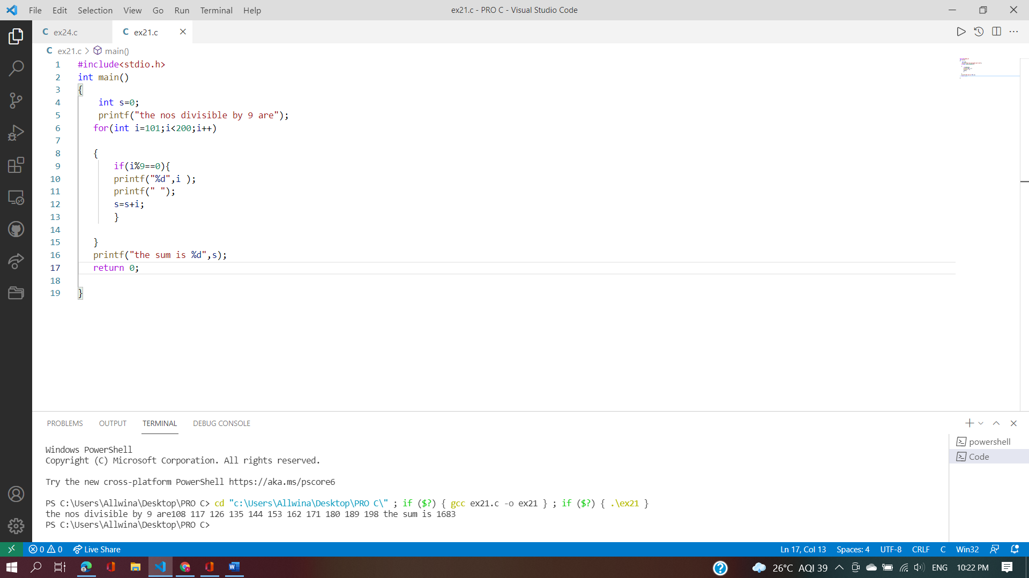

**2.23 Write a program in C to find the prime numbers within a range of numbers.**

**Test Data :**

**Input starting number of range: 1**

**Input ending number of range : 50**

**Expected Output :**

**The prime number between 1 and 50 are :**

**2 3 5 7 11 13 17 19 23 29 31 37 41 43 47**

**2.24 Write a C program to display Pascal's triangle**

